**Model Development Phase Template**

|  |  |
| --- | --- |
| Date | 18 June 2025 |
| Team ID | SWTID1749709635 |
| Project Title | Mental Health Prediction |
| Maximum Marks | 4 Marks |

**Initial Model Training Code, Model Validation and Evaluation Report**

The initial model training code will be showcased in the future through a screenshot. The model validation and evaluation report will include classification reports, accuracy, and confusion matrices for multiple models, presented through respective screenshots.

**Initial Model Training Code:**

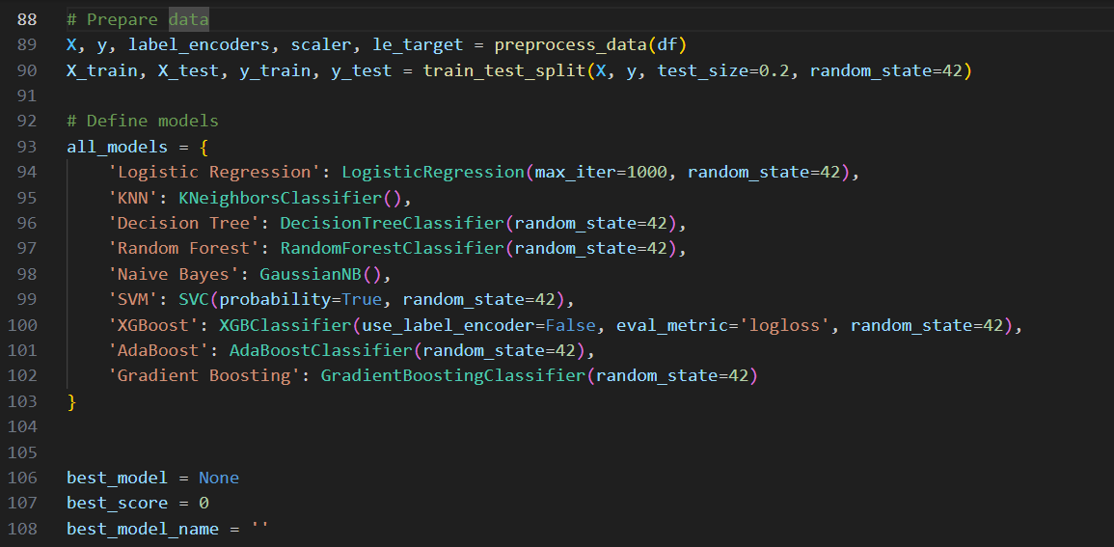

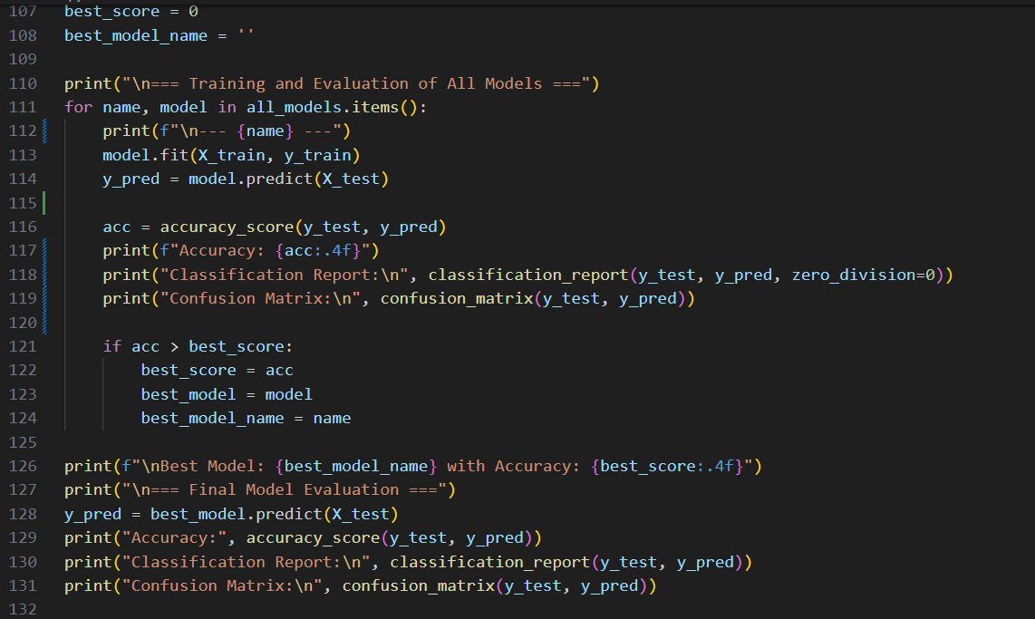

**Model Validation and Evaluation Report:**

|  |  |  |  |
| --- | --- | --- | --- |
| **Model** | **Classification Report** | **Accuracy** | **Confusion Matrix** |
| Logistic Regression |  | 0.7559 |  |
| K-Nearest Neighbors |  | 0.7165 |  |
| Decision Tree |  | 0.8504 |  |
| Random Forest |  | 0.9213 |  |
| Naïve Bayes |  | 0.7205 |  |
| Support Vector Machines |  | 0.7795 |  |
| Extreme Gradient Boosting |  | 0.8701 |  |
| Adaptive Boosting |  | 0.7480 |  |
| Gradient Boosting |  | 0.8386 |  |